Mosaic Rhyme

🔹 What is Mosaic Rhyme
# Source: AI Source: Provided by: [Data Path: Persons Table -> ID Column: 1, Name_En Column: Motasem Essam] -> From: [Chatgpt (GPT-4-turbo)] on [8/2/2025]
⚠️ Mosaic rhyme is a poetic technique, not a true type of homograph.
However, homographs may be used creatively within mosaic rhymes, especially when they contribute to syllabic or rhythmic flexibility.

✅ Definition of Mosaic Rhyme
# Source: AI Source: Provided by: [Data Path: Persons Table -> ID Column: 1, Name_En Column: Motasem Essam] -> From: [Chatgpt (GPT-4-turbo)] on [8/2/2025]
A mosaic rhyme is a rhyme in which a single multisyllabic word is matched with multiple shorter words that together produce the same rhyming sound pattern.
🔹 It's called “mosaic” because the rhyme is "broken" into pieces across multiple words.

🧠 Key Features of Mosaic Rhyme
# Source: AI Source: Provided by: [Data Path: Persons Table -> ID Column: 1, Name_En Column: Motasem Essam] -> From: [Chatgpt (GPT-4-turbo)] on [8/2/2025]
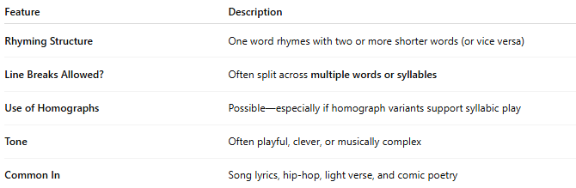
Feature | Description
Rhyming Structure | One word rhymes with two or more shorter words (or vice versa)
Line Breaks Allowed? | Often split across multiple words or syllables
Use of Homographs | Possible—especially if homograph variants support syllabic play
Tone | Often playful, clever, or musically complex
Common In | Song lyrics, hip-hop, light verse, and comic poetry

📝 Examples of Mosaic Rhyme

🔸 Example 1:
# Source: AI Source: Provided by: [Data Path: Persons Table -> ID Column: 1, Name_En Column: Motasem Essam] -> From: [Chatgpt (GPT-4-turbo)] on [8/2/2025]
He always tried to complicate
But I just told him: calm, be late
- complicate rhymes with calm / be / late
✅ Mosaic rhyme

🔸 Example 2 (with a homograph “bass”):
# Source: AI Source: Provided by: [Data Path: Persons Table -> ID Column: 1, Name_En Column: Motasem Essam] -> From: [Chatgpt (GPT-4-turbo)] on [8/2/2025]

She played a tune with heavy bass (/beɪs/)
That shook the room in every case
- Homograph “bass” (instrument) pronounced /beɪs/
- Rhymes with “every case” = ✅ Mosaic rhyme using a homograph

🧪 Using Homographs in Mosaic Rhyme
# Source: AI Source: Provided by: [Data Path: Persons Table -> ID Column: 1, Name_En Column: Motasem Essam] -> From: [Chatgpt (GPT-4-turbo)] on [8/2/2025]
Homographs with multiple syllables or multiple meanings work best when they:
- Match the syllable count of the broken words
- Fit the rhyming sound when read aloud

✅ Example with “lead” (homograph):
# Source: AI Source: Provided by: [Data Path: Persons Table -> ID Column: 1, Name_En Column: Motasem Essam] -> From: [Chatgpt (GPT-4-turbo)] on [8/2/2025]
I had to lead the silent team
Through fog and noise — a violent dream
- “lead” as verb (/liːd/) doesn’t create mosaic rhyme here.
Now tweak:
The sky was thick with pipes of lead
My boots were sinking in the bed
- “lead” (/lɛd/) rhymes with “in the bed”
✅ This is a subtle mosaic rhyme using a homograph

✅ Summary
# Source: AI Source: Provided by: [Data Path: Persons Table -> ID Column: 1, Name_En Column: Motasem Essam] -> From: [Chatgpt (GPT-4-turbo)] on [8/2/2025]
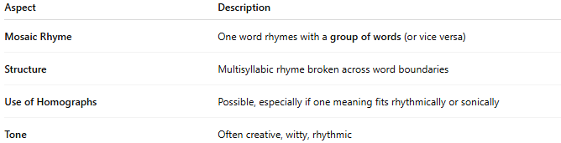
Aspect | Description
Mosaic Rhyme | One word rhymes with a group of words (or vice versa)
Structure | Multisyllabic rhyme broken across word boundaries
Use of Homographs | Possible, especially if one meaning fits rhythmically or sonically
Tone | Often creative, witty, rhythmic

